Dear parents/guardians,
And just like that we’re in the final half term of Year 3! I hope you all enjoyed the sunshine over the half term break and took the chance to recharge some batteries! Our whole school topic for this half term is “Journeys” which will see us in Class 3 exploring the journey Ancient Egyptians believed took place in the afterlife. I know that we have lots of budding Egyptologists amongst us in Class 3 and I cannot wait to get stuck in with this historical focus.

Reading
Class 3 constantly impress me with their enthusiasm and eagerness when it comes to reading and their progress over the year has been truly wonderful. Your encouragement and support with reading at home is, as always, much appreciated. Children should continue to read aloud or share a book with an adult at home most days and be recorded in their ‘Fish book’ by the adult. Even if it is not their school reading book, I love hearing about any other books you are enjoying at home so please feel free to record this in the fish book. Please ensure that children have their Fish book and reading book in school every day so that our reading sessions can be recorded. Each week, children will be heard reading as part of whole class guided reading sessions as well 1:1 with myself. I do aim to hear each child at least once a week but sometimes time just flies! If I don’t get the chance to hear your child 1:1 in a week, they will always be top of my list the following week.

Homework and spellings
Homework will be set on a Friday to be returned the following Tuesday, with spellings stuck in children’s fish books on a Wednesday. I will continue to set some homework tasks using the online learning platform “Purple Mash”. Children have had lots of practice logging onto this at school and their login details can be found on the inside cover of their fish books.

PE
Whilst our regular PE day is Tuesday, the summer term is always a great opportunity for making the best of the weather and getting out! Therefore, please ensure children have their PE kit in school all week to allow them to join in. Please also ensure that children have hairbands for long hair to be tied back if needed.

Maths
This half term, we will be looking at measurement (length), finding the perimeter of shapes and telling the time in maths! Whilst we do practice telling the time using the classroom analogue and my computer digital clock at school, it would be incredibly beneficial to practice telling the time and simple time problems (e.g. we’re having dinner at 6 o’clock, how long until dinner? Our car journey to school is 10 minutes, what time will we arrive if we set off at…) at home where possible.
Any additional practicing of the times table/division facts for year 3 (2,3,4,5,8,10) at home is always incredibly valuable too! There are lots of different ways to practice these and the “Purple Mash” website has lots of games (and rather exciting songs…) to help practice these. The times table facts children are expected to be fluent in by the end of year 3 are stuck in the inside cover of their homework books and these can be referred to for homework tasks if children are not confident in the quick recall of the facts.

If you have any concerns or queries regarding anything on here or otherwise, please don’t hesitate to drop me an email: abrearey@willowbrook.notts.sch.uk
Miss Brearey

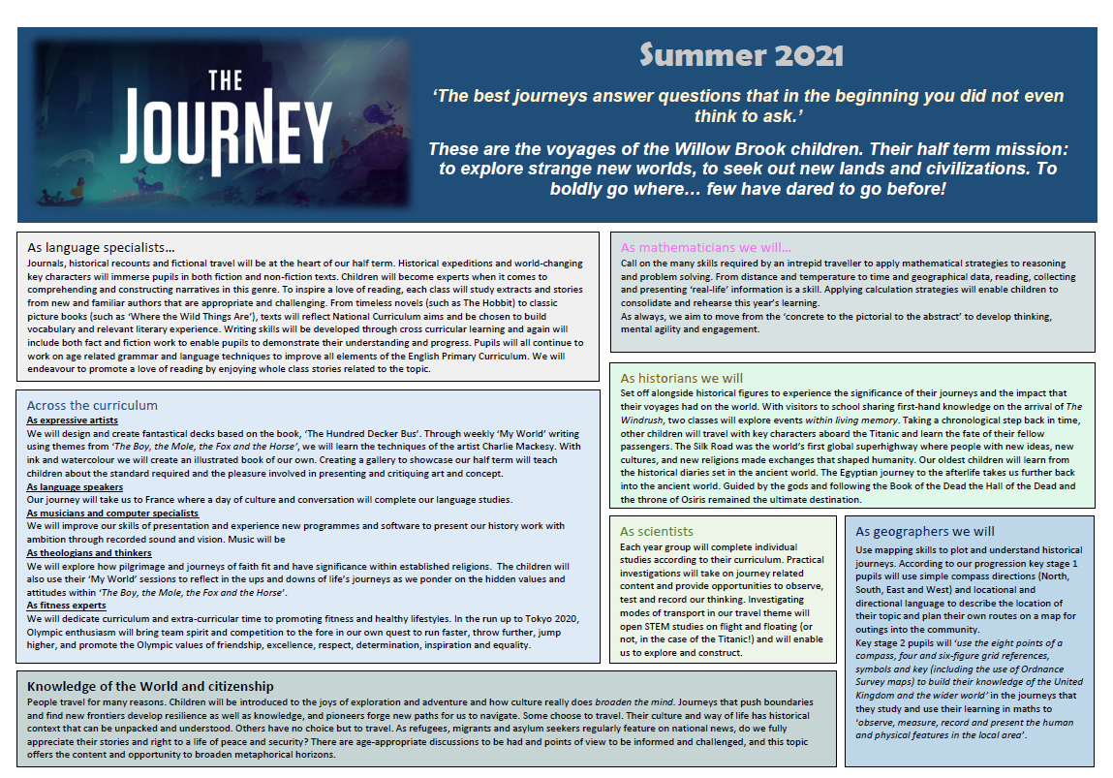
s

