T.A. Vacancy (Grade 2)

Dear prospective applicant,

On behalf of the community at Willow Brook Primary School, I would like to thank you for your interest in applying for a position at our school. The information on our website should provide you with a good understanding of our ethos, but I would strongly encourage you to visit the school as well. If you like what you see, then we look forward to receiving your application.

We are a successful school with much to offer. I am proud of the many and diverse achievements of our pupils and our staff; impressed by the quality of behaviour and engagement around the school and know how hard each member of the community works to make this a great place to achieve and learn. Our pupils encounter far more than academic success, discovering new talents within a learning environment that is happy, where they feel valued, safe, secure and aware of the needs of others. The school benefits from a collaborative and supportive environment which strives for constant improvement.

If you have the skills and enthusiasm to be a part of our team, we look forward to hearing from you.

What to do next:
• visit the school if you are able – email Zoe Roper, our Office Manager at office@willowbrook.notts.sch.uk or call on 0115 914 9889 to arrange your visit
• complete the application form (available from the school website or upon request from the office)
• submit your application with a covering letter, which should outline how you could meet the challenges and potential of the role

I hope you will find all the information you need on our website, but please do not hesitate to contact myself or the school for any further information you require about the post.

We look forward to receiving your application.

Yours faithfully,
Louise Ballard
Head Teacher
head@willowbrook.notts.sch.uk

Our School Ethos

CREATIVITY
COMMUNITY
COMMITMENT
CARE
CONFIDENCE
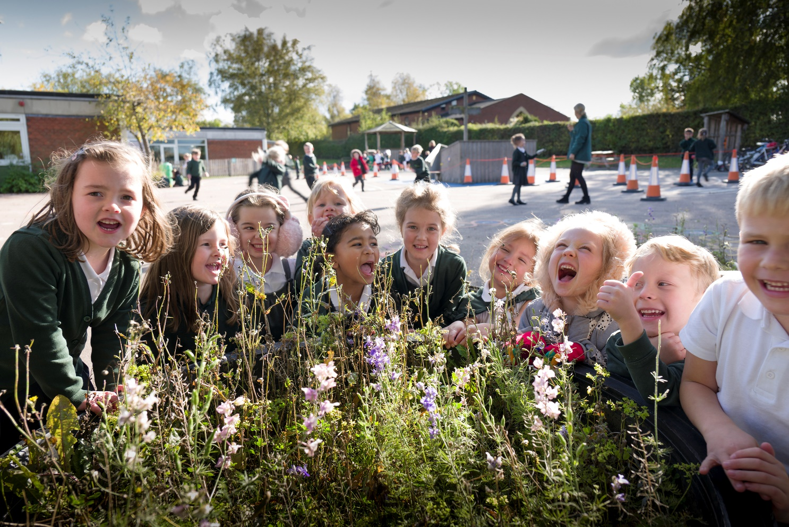

We believe that these five words sum up our aims for our children very well. They are displayed around school, and we call them our five Cs.

‘I am at the heart of a happy community where a love of learning and a wealth of challenges and opportunities inspire my confidence, creativity and talents.
I am at the heart of a caring community where I learn to respect and value my environment and the people who share it with me.
I am committed to becoming the best I can be – a lifelong learner where those around me celebrate and encourage the start of my unique learning journey.
I am at the heart of my school and am proud to be so.’

Grade 2 teaching assistant (initially one year depending on funding)

‘The successful candidate will work within our Foundation Stage Unit, providing close 1:1 supervision and care for an ASD child joining our school community in September 2021. Alongside the EYFS staff team, they will support the child’s individual learning and personal needs. Further information will be shared with applicants upon request.’

Key duties
1. Support learning activities under the professional direction and supervision of a qualified teacher, differentiating and adapting learning programmes to suit the needs of allocated pupils with SEND.
2. Plan and evaluate specialist learning activities with the teacher, writing reports and records as required.
3. Work with pupils on individual care programmes, designed and supervised by a professional.
4. Monitor, assess, record and report on development, progress and attainment, as agreed with the teacher
5. Select and adapt appropriate resources/methods to facilitate agreed learning activities.
6. Be involved in planning, organising and implementing individual development plans for pupils (such as Individual Educational Plans), as required
7. Attend to pupil’s personal needs including toileting, hygiene, dressing and eating
8. Work positively with the EYFS team to promote inclusion and equality and

Knowledge and skills:
Relevant qualifications
Experience of working with SEND children
Knowledge and compliance with policies and procedures relevant to child protection and health and safety.

