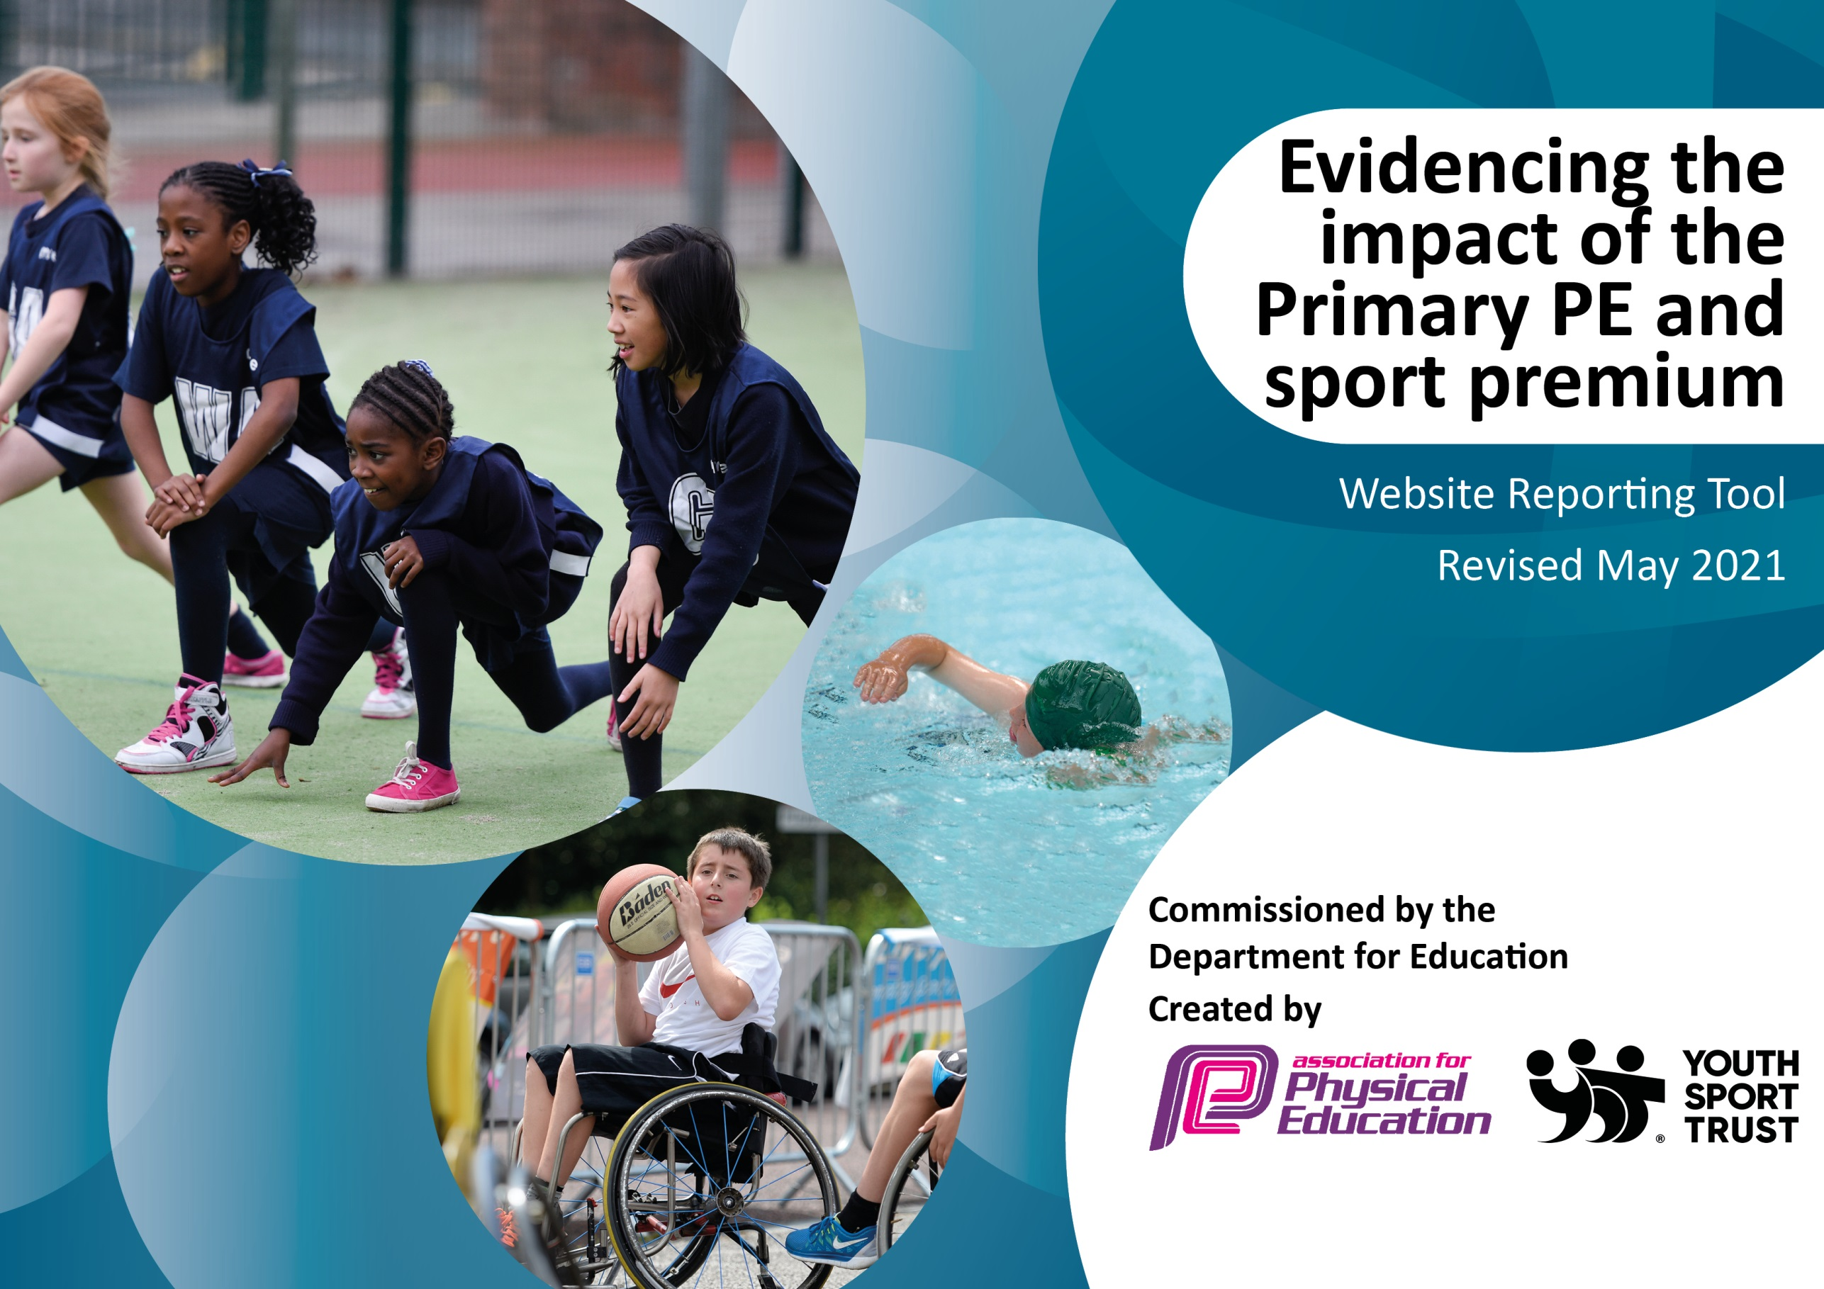

It is important that your grant is used effectively and based on school need. The Education Inspection Framework (Ofsted 2019 p64) makes clear there will be a focus on ‘whether leaders and those responsible for governors all understand their respective roles and perform these in a way that enhances the effectiveness of the school’.

Under the Quality of Education criteria (p41) inspectors consider the extent to which schools can articulate their curriculum (INTENT), construct their curriculum (IMPLEMENTATION) and demonstrate the outcomes which result (IMPACT).

To assist schools with common transferable language this template has been developed to utilise the same three headings which should make your plans easily transferable between working documents.

Schools must use the funding to make additional and sustainable improvements to the quality of Physical Education, School Sport and Physical Activity (PESSPA) they offer. This means that you should use the Primary PE and sport premium to:

- Develop or add to the PESSPA activities that your school already offer
- Build capacity and capability within the school to ensure that improvements made now will benefit pupils joining the school in future years
- The Primary PE and sport premium should not be used to fund capital spend projects; the school’s budget should fund these.
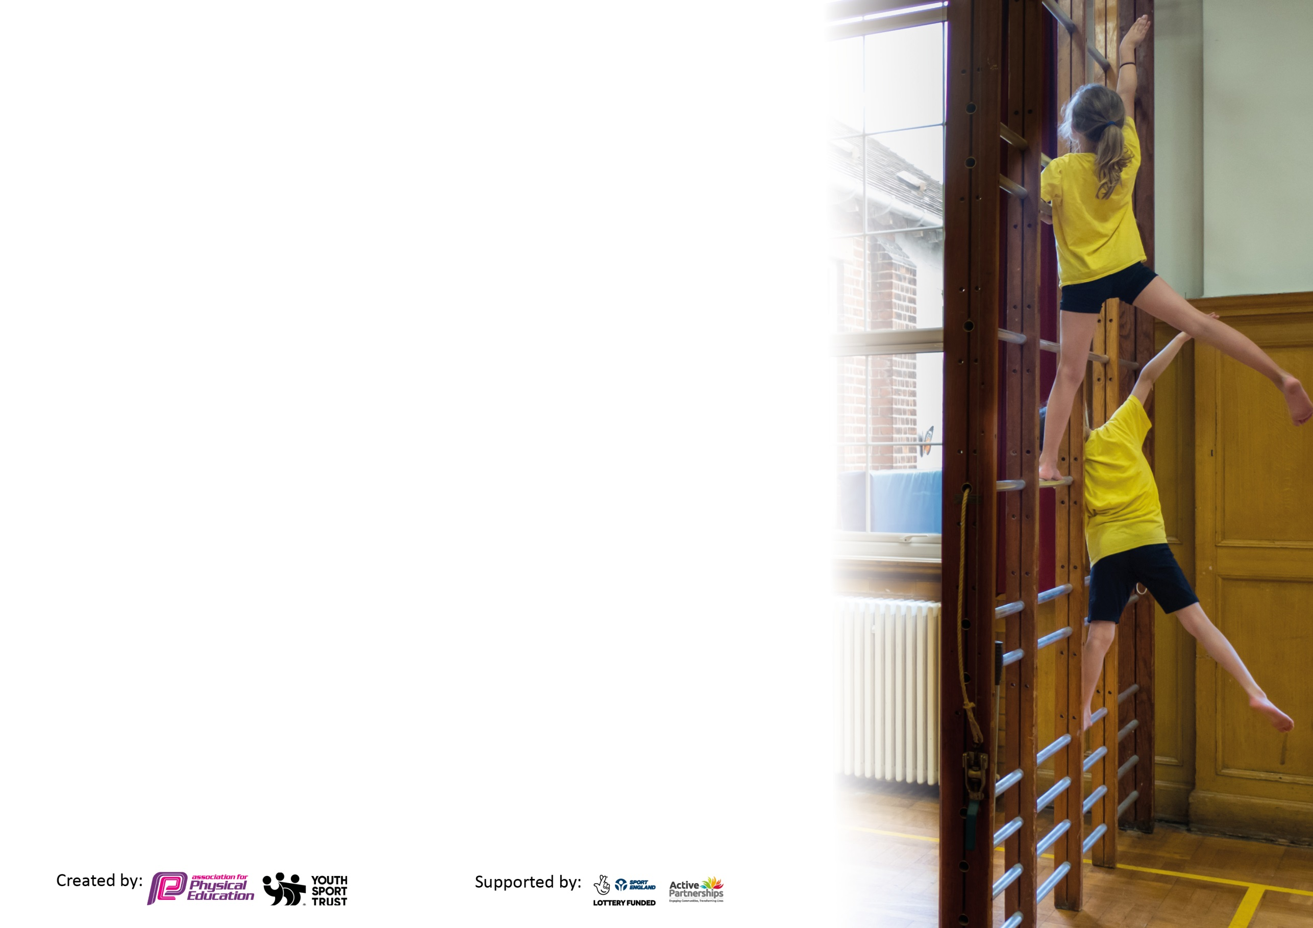
Please visit gov.uk for the revised DfE guidance including the 5 key indicators across which schools should demonstrate an improvement. This document will help you to review your provision and to report your spend. DfE encourages schools to use this template as an effective way of meeting the reporting requirements of the Primary PE and sport premium.

We recommend you start by reflecting on the impact of current provision and reviewing the previous spend.

Schools are required to publish details of how they spend this funding, including any under-spend from 2019/2020, as well as on the impact it has on pupils’ PE and sport participation and attainment by the end of the summer term or by 31st July 2021 at the latest.

We recommend regularly updating the table and publishing it on your website throughout the year. This evidences your ongoing self-evaluation of how you are using the funding to secure maximum, sustainable impact. Final copy must be posted on your website by the end of the academic year and no later than the 31st July 2021. To see an example of how to complete the table please click HERE.

Please note: Although there has been considerable disruption in 2020 it is important that you publish details on your website of how you spend the funding - this is a legal requirement.
Support for review and reflection - considering the 5 key indicators from DfE, what development needs are a priority for your setting and your pupils now and why? Use the space below to reflect on previous spend and key achievements and areas for development.

N.B. In this section you should refer to any adjustments you might have made due to Covid-19 and how these will influence further improvement.
Key achievements to date until July 2020: | Areas for further improvement and baseline evidence of need:
- Employment of PE Teaching assistant is still a major benefit to ensuring curriculum coverage and improving staff CPD.  - Continued to promote active learning at home throughout COVID lockdowns.  - Pre-COVID competition attendance was good across KS2.  - Pre-COVID Year 5 and 6 Sport Leader training was underway. | - Work towards the School Games Mark to further improve our curriculum provision.  - Continue to develop KS2 leadership and sports leaders.  - Develop links between community clubs and provide more enrichment days and experiences.  - Continue to develop staff CPD and raise the profile of active lessons across the curriculum.

Did you carry forward an underspend from 2019-20 academic year into the current academic year? YES/NO * Delete as applicable
Total amount carried forward from 2019/2020 £6,652.11
+ Total amount for this academic year 2020/2021 £17,586
= Total to be spent by 31st July 2021 £24,238.11
Meeting national curriculum requirements for swimming and water safety.

N.B Complete this section to your best ability. For example you might have practised safe self-rescue techniques on dry land which you can transfer to the pool when school swimming restarts.
Due to exceptional circumstances priority should be given to ensuring that pupils can perform safe self rescue even
if they do not fully meet the first two requirements of the NC programme of study.
What percentage of your current Year 6 cohort swim competently, confidently and proficiently over a distance of at least 25 metres?  N.B. Even though your pupils may swim in another year please report on their attainment on leaving primary school at the end of the summer term 2021.  Please see note above. | 93%
What percentage of your current Year 6 cohort use a range of strokes effectively [for example, front crawl, backstroke and breaststroke]?  Please see note above. | 93%
What percentage of your current Year 6 cohort perform safe self-rescue in different water-based situations? | 93%
Schools can choose to use the Primary PE and sport premium to provide additional provision for swimming but this must be for activity over and above the national curriculum requirements. Have you used it in this way? | Yes/No

Action Plan and Budget Tracking
Capture your intended annual spend against the 5 key indicators. Clarify the success criteria and evidence of impact that you intend to measure to evaluate for pupils today and for the future.

Academic Year: 2020/21 | Total fund allocated: £17,586 | Date Updated: 8th July 2021
Key indicator 1: The engagement of all pupils in regular physical activity – Chief Medical Officers guidelines recommend that primary school pupils undertake at least 30 minutes of physical activity a day in school |  |  |  | Percentage of total allocation:
 |  |  |  | 62%
Intent | Implementation |  | Impact
Your school focus should be clear what you want the pupils to know and be able to do and about  what they need to learn and to  consolidate through practice: | Make sure your actions to achieve are linked to your intentions: | Funding allocated: | Evidence of impact: what do pupils now know and what can they now do? What has changed?: | Sustainability and suggested next steps:
- To ensure that children are taking part in a teacher taught PE lesson each week. | - Teachers to submit weekly planning timetables showing coverage in a week. | £400  Time for SJ to monitor planning and complete any PE tasks. | Timetables have been adapted due to some time spent home learning and catching up on other curriculum learning – children received 1 hour per week as a minimum plus any additional lessons during the week. | To work towards every class receiving 2 hours worth of curriculum teaching starting in September. SJ to ensuring monitoring of this through planning.
- Provide all children with a session of PE lead by our PE Teaching Assistant each week. | - SJ to work alongside PE Teaching Assistant to plan lessons.  - PE Teaching Assistant to submit lesson planning to SJ weekly. | £14,704  60% of PE Teaching Assistants salary | Lessons are planned and delivered by expert coach. Children are learning more technical skills, game play and focus on sportsmanship. | Continue to employ Teaching Assistant to teach a session a week to each class.  Implement playground games and sport leader programme in September.  Provide more planning time for PE TA to ensure planning is thorough.
Key indicator 2: The profile of PESSPA being raised across the school as a tool for whole school improvement |  |  |  | Percentage of total allocation:
 |  |  |  | 3%
Intent | Implementation |  | Impact
Your school focus should be clear what you want the pupils to know and be able to do and about  what they need to learn and to  consolidate through practice: | Make sure your actions to achieve are linked to your intentions: | Funding allocated: | Evidence of impact: what do pupils now know and what can they now do? What has changed?: | Sustainability and suggested next steps:
- Look at the progression of the curriculum across KS1 and KS2. | - SJ to develop a curriculum progression document from EYFS to KS2 to ensure staff know what they should be covering in their year groups. | SJ – £400  PE time on a Thursday | - Planning should now follow a sequence of learning to ensure progression across the curriculum. | - This will be implemented from September ready for 21/22.
- To ensure Link Governor is up to date on policies and main aims of our Sport funding. | - SJ to meet with Link Governor to go through the PE and Sport budget and our main aims for the funding. Link Governor then to report back to governor meetings. | £195 to cover SJ time meeting link governor. | - In person meeting did not take place due to COVID. Head teacher feedback information during governor meetings online instead. | - To put a meeting in place with Link Governor to go through up-to-date documents as soon as possible.
- Increase the community link and promoting PE and sport achievements to parents. Raise the profile of school sport in the wider community and celebrate achievements. | - SJ, TC and LB to ensure that the website is up to date with match reports.  - SJ and TC to feedback in whole school assemblies.  - LB to include match scores on newsletters out to parents. | PE time for SJ on a Thursday (covered in the amount above) | - Children feel a sense of pride in their achievements.  - Parents are aware of celebrations taking place and the importance of school sport. | - To continue to make this a priority and to ensure all staff are aware of promoting PE lessons and competition achievements.

Key indicator 3: Increased confidence, knowledge and skills of all staff in teaching PE and sport |  |  |  | Percentage of total allocation:
 |  |  |  | 3%
Intent | Implementation |  | Impact
Your school focus should be clear | Make sure your actions to | Funding | Evidence of impact: what do | Sustainability and suggested
what you want the pupils to know | achieve are linked to your | allocated: | pupils now know and what | next steps:
and be able to do and about | intentions: |  | can they now do? What has
what they need to learn and to |  |  | changed?:
consolidate through practice:
- To continue to build on staff CPD and be up to date on relevant documentation and requirements. | - SJ to attend Subject Leader meetings through the Rushcliffe Partnership and feedback relevant information to staff in staff meetings. | £585 - to cover supply of Yr2 for 3 meetings through the year. | - In person meetings did not take place due to COVID so funding was not needed.  - SJ up to date with information passed out electronically and forwarded on to relevant staff members. | SJ and TC to engage with the meetings next academic year and to have time to feedback to staff.
Key indicator 4: Broader experience of a range of sports and activities offered to all pupils |  |  |  | Percentage of total allocation:
 |  |  |  | 29%
Intent | Implementation |  | Impact
Your school focus should be clear | Make sure your actions to | Funding | Evidence of impact: what do | Sustainability and suggested
what you want the pupils to know | achieve are linked to your | allocated: | pupils now know and what | next steps:
and be able to do and about | intentions: |  | can they now do? What has
what they need to learn and to |  |  | changed?:
consolidate through practice:
- Provide good quality equipment for a range of sports to ensure the full range of the curriculum is being taught. | - Audit equipment each term and order replacement items or new equipment that is needed. | £2,000 Equipment to be purchased | - Teachers have access to good resources to ensure they can teach the relevant curriculum areas.  - Children all have access to equipment to ensure they are actively involved in the lessons as much as possible to limit waiting time for shared equipment. | - Continue to audit equipment and replace throughout the year as needed.  - Speak with staff to see if any additional equipment needs purchasing to teach their sports of interest.
- Broaden the activities offered to each class. | - SJ to organise timetable of content to be taught each half term by teachers/sports leader.  - Classes to go out on PE trips or to have experienced coaches into school – links with the local community.  - Sports Week to be planned for classes to try new sports. | £5000  Days out, coaches in school, community events. | - COVID impacted the amount of trips and having coaches into school.  - Sport week was a success and children took part in sport every day. New sports/games were shared to broaden their experiences. | - Continue to explore exciting opportunities to go out into the community and to have themed days/weeks linked to sport.

Key indicator 5: Increased participation in competitive sport |  |  |  | Percentage of total allocation:
 |  |  |  | 3%
Intent | Implementation |  | Impact
Your school focus should be clear | Make sure your actions to | Funding | Evidence of impact: what do | Sustainability and suggested
what you want the pupils to know | achieve are linked to your | allocated: | pupils now know and what | next steps:
and be able to do and about | intentions: |  | can they now do? What has
what they need to learn and to |  |  | changed?:
consolidate through practice:
- To work towards achieving the school’s games mark by attending different levels of competition. | - SJ and TC to explore the requirements to achieve a bronze or silver award for the school.  - Meet with CB to submit award evidence. | 3 meetings out for SJ during the year (covered in supply funding above) | Not explored fully due to COVID but time has been spent putting plans into place ready for September. | Continue with application for School Games Mark.
- Ensure children are given the opportunity to take part in competitive events. | - Provide inter and intra competition opportunities for KS1 and KS2.  - Track children attending competitive team events and target those that have not had the opportunity. | £600  Additional hours for TA’s salary if needed to cover out of school events. | Competitions stopped due to COVID guidance.  Competitive personal best style activities sent home for home learning and used within face-to-face teaching when appropriate. | Set up systems to track children’s attendance and data ready for September.

Signed off by
Head Teacher:
Date:
Subject Leader: | S.Johnston
Date: | 15th July 2021
Governor:
Date:

