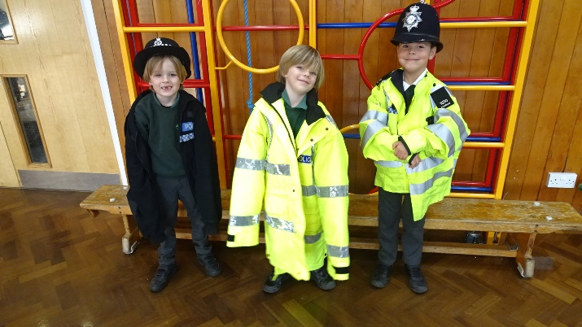
Dear parents/carers of Class 1,

I hope that you have all had a restful half term week, I cannot believe we are now halfway through the year already!? Last half term was a busy one, full of progress, learning and some exciting visitors…!
Our whole school topic this half term is all about Connections, overleaf are further details of this…
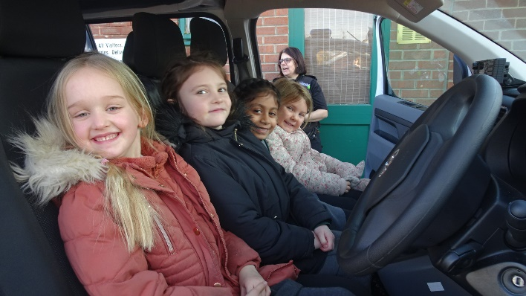

Reading
Thank you so much for your support with reading at home. Their progress has been so clear to see and they are rightfully pleased when they are told that they are ready for some more challenging books. The expectation continues that children are reading aloud their school reading book with an adult (or older sibling!) at home each day and that this is recorded in their Monkey book by the adult (or older sibling!).

Please ensure that children have their reading record and reading book in school every day so that our reading sessions can be recorded and books changed. We continue to aim to change reading books daily when we can see from the monkey book that a book has been read. Each week, children will be heard reading aloud 1:1 by an adult in school at least once a week to continue to aid fluency, support important comprehension skills and build that all important love of reading! Your support with this at home is invaluable.

Phonics folders will continue to be sent home each week on Friday for you to interact with at home- please ensure they are back in school on Monday!

Homework
As has become the routine, homework will continue to be set on a Friday to be returned the following Tuesday. Our spelling quiz will also continue to be on a Friday.

This half term, we will be continuing to practice our adding/subtracting skills using a variety of resources and techniques before moving on to looking at place value with numbers up to 50. Any continued practice of counting, addition and/or subtraction at home would be incredibly valuable- using any materials you have to hand!

Our PE days this half term will be Tuesday and Thursday. Please ensure children have a full kit in school so that they can take part in our lessons.

If you have any concerns or queries regarding anything on here or otherwise, please don’t hesitate to call me via the school office or catch me on the playground.
Mrs Humphrey

