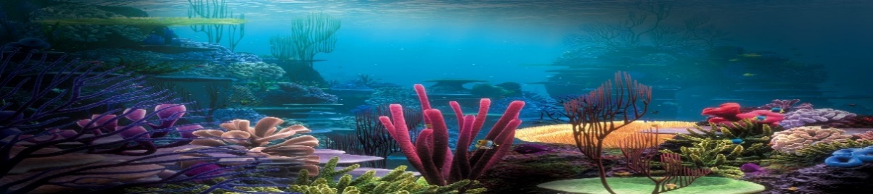

The Big Idea…

As the great explorer Robert Ballard said, ‘*The deep sea is the largest museum on earth. It contains more history and hidden knowledge that all the museums on land combined. And yet, we are only now starting to find it.*’ Set sail with a sense of adventure and curiosity with our fast-flowing topic this term. We will be diving into the depths of the unknown as we discover more about the water that makes up over 70% of our planet. The oceans and seas are home to unbelievable creatures beyond our wildest imagination, and if you look carefully enough, there are treasures in abundance. We will also be learning about man’s impact on the seas and coastlines and how we MUST take action to ensure that our oceans are clean and full of life for future generations.

As mathematicians we will…

be comparing and measuring length/height as well as weight and capacity in different contexts linked to our topic. We will be introducing multiplication and division as we look at counting in 2s, 5s and 10s whilst also thinking about what makes an even group and how we can share equally. We will look at the importance of fractions and how shapes, groups of objects and numbers can be split into half and quarter. Throughout the term, we will be developing our abilities to problem solve using our maths skills and start to be able to explain and reason our mathematical thinking.

As language specialists, we will…

submerge ourselves into our underwater topic as we explore and meet the coast and its creatures through fiction and non-fiction texts. We will catch the rip tide with The Snail and the Whale, send seaside postcards as we read At the Beach by Roland Harvey and reacquaint ourselves with Traction Man as he goes off on his Beach Odyssey. Non-fiction texts such as Look What I found at the Seaside by Moira Butterfield will show us how to write factual information books. We will also be learning about suffixes and prefixes to change the meaning of words*.* Our trip to Rushcliffe Country Park will recap our knowledge of fairy tales and give us opportunity to write first hand accounts. We will continue to build our stamina for writing as well as impressing the importance of pride in our work.

As scientists we will…

Learn about the characteristics of fish, amphibians, birds and mammals, identifying similarities and differences between them, and use these to classify different sea creatures into categories. We will learn about the terms, *‘carnivore, herbivore and omnivore’* and explore some of the eating habits of different coastal creatures.

We will learn more about the variety of other animals who have adapted to use the world’s oceans and coasts for their own survival. From seabirds to shelled reptiles there’s a wealth of knowledge to investigate.

As geographers and historians, we will…

develop our knowledge of the world’s oceans by being able to name and locate them on a world map. We will learn facts about the creatures that call the oceans their home. We will also explore the types of creatures that can be found in the different oceans and the conditions in which they live, including the land and seas around the UK. We will look at the history of the seaside holiday through postcards and photographic sources. Geography and history will combine as we begin to understand why it is so important for us to cut down on our plastic usage, replacing it with effective alternatives.

Across the curriculum…

**As musicians**

We will be using the different habitats of animals as inspiration for our music with Andy’s raps as a starting point.

**As expressive artists**

We will be looking at pieces of art by Matisse and Escher. We will look at the shapes and colours of the sea that inspired Matisse in his pieces titled Oceania.

**As fitness experts**

We will be learn the rules of scatter ball and engage in intra- and inter- class games to develop our throwing skills.

**Religious education**

We will be learning about what life is like for Christians and Jewish people. We will learn about some of the day to day religious routines and beliefs that guide how they live their life.

**In PSHE**

We will be thinking about how we can keep ourselves happy and healthy. We will think about the importance of the food we eat and the activities that help keep our hearts and minds healthy.

**Knowledge of the World**

What is the difference between a sea and an ocean?

Why do we know more about space than we do about the oceans? And why is seawater salty?

**Citizenship**

How do we take responsibility for ourselves and our planet and be good citizens, even if we are very young?

**Ambitious thinking**

We will meet new animals that are bigger and more mind blowing than any we have met! From the gargantuan to microscopic and the anatomically unexplainable…

Life on the ocean waves