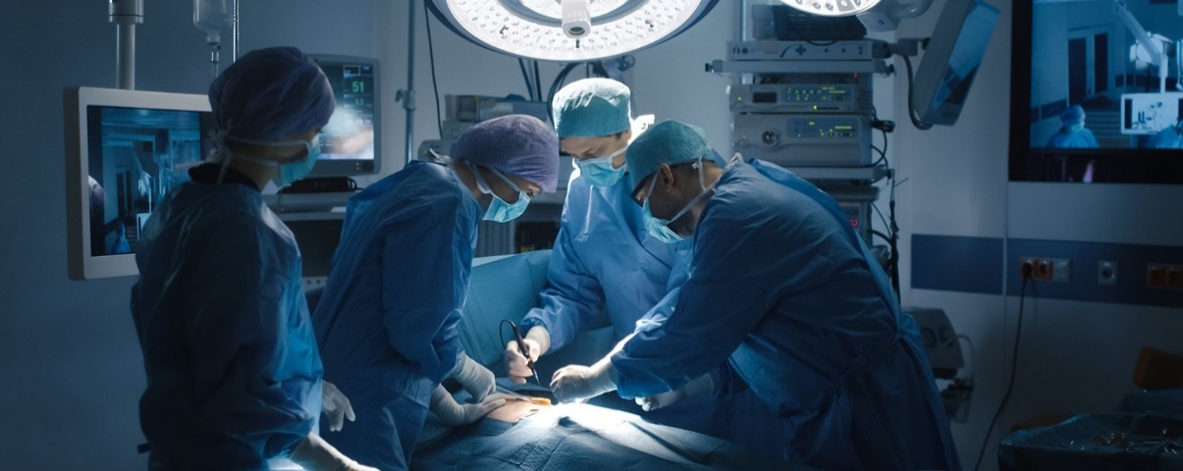

**Alive and Kicking**

The Big Idea…

Life expectancy in the United Kingdom has been steadily rising since the turn of the 19th century. Improvements in diet, lifestyle and medical care have all played a huge roll in this and we are going to find out how. We will study the history of medicine across the world and come to understand some of the incredible breakthroughs that have contributed to our vastly improved quality of life. We will learn about amazing abilities of doctors through our story *Pig-Heart Boy* but also learn about their limits. As the children prepare for the next stage in their life, we will learn about the importance of looking after ourselves to stay fit and healthy, both mentally and physically.

As mathematicians we will

We will be moving onto some of the very last steps in the primary maths curriculum. We now turn our attention to problem solving, pulling in a range of different skills from interpreting pie charts and pictograms to more complex tables and charts. We will be handling data in our science lessons and creating pie charts in maths lessons. We will identify trends and draw conclusions using large datasets such as those gathered in the classes PE lessons.

As language specialists we will… explore mature and challenging themes through the critically acclaimed writing of Malorie Blackman and inspirational and courageous author who held the position of Children’s Laureate. We will undertake an in-depth analysis of *Pig-Heart Boy*, one of her most thought provoking works. It engages children with its hefty emotional content and relatable characters. The words of Blackman will also guide our pens as we learn from the best and create our own pieces of writing to be proud of. Alongside this rich literature, the children will learn to write using scientific language as we learn about the human body. Finally, the children will merge the two with a study of early science fiction. The children will be enraptured by the high alpine scenery and dark forces of Mary Shelly’s *Frankenstein;* be gripped by the action-packed altercations of Bram Stoker’s Dracula and chilled by the haunting effects of chemical concoctions in Robert Stevenson’s *Dr Jekyl and Mr Hyde*.

As geographers we will

be tracking the journeys of exotic gothic monsters as they are pursued across the globe. We will recap our knowledge of the alpine regions as Frankenstein’s monster taunts his creator. we will compare and contrast the Yorkshire coast with the hustle and bustle of London and the soaring solitude of Transylvania as we follow the story of Dracula.

*‘Pupil should be taught to name and locate counties and cities of the United Kingdom, geographical regions and their identifying human and physical characteristics, land-use patterns; and understand how some of these aspects have changed over time…human geography, including: types of settlement and land use, economic activity including trade links, and the distribution of natural resources.’*

As historians we will

Take a thematic approach in understanding the rich history of medicine across the ages. From the early teaching of the Greek physician Galen, through the medieval understanding of plague and infection, right up to modern sports scientists pushing their athletes to the limits of human strength and endurance.

*‘Pupils should be taught a study of an aspect or theme in British history that extends pupils’ chronological knowledge beyond 1066 that details a significant turning point in British history, for example … the Battle of Britain.’*

As scientists we will

be developing our knowledge of the human body as we learn about blood, the circulatory system and the heart. Once we’ve understood the mechanics of this system, we’ll learn how best to care for it. After all, you only get one body!

*‘identify and name the main parts of the human circulatory system, and describe the functions of the heart, blood vessels and blood’*

*‘recognise the impact of diet, exercise, drugs and lifestyle on the way their bodies function.’*

‘*describe the ways in which nutrients and water are transported within animals, including humans’.*

Across the curriculum

**As musicians** we will explore the idea of pulse and beat within music. We will listen and engage with famous works such as Trepak from The Nutcracker by Tchaikovsky and Scherzo from The Firebird Suite by Stravinsky

**As expressive artists** we will learn how artists have been fascinated by the human form since beginning of time. Taking a weekly approach, we will study how hands, feet, hair and torsos have been depicted by the finest painters and sculptors that have ever lived.

**As philosophers** we will be discussing the morality of medical science. From animal testing to discussions about the quality of life, the classroom will be full of healthy debate

**As fitness experts** we will be investigate the effects of exercise on our body. We will observe and understand not only the immediate effects of exertion on heartrate and breathing, but also learn about how athletic performance can be improved over time with periods of training, rest and recovery. The children will also get the opportunity to experience the effects of these scientific discoveries first hand. In taking a six week netball course, the children will test their balance, coordination and most importantly, their team work.

**Knowledge of the World** Understanding the complexities of human health is an essential skill to living in a shared world. Though this creative topic, we will learn more about how healthcare is provided and how precious it is.

**Citizenship** Living a healthy life is an important part of citizenship. Through our DARE program the children have learned how to be safe and responsible young adults. We will be prepared for those next important steps in life.

**Ambitious thinking** As advances in medicine continue, and bills for social care and the NHS continue to soar, at what point do we put a price on human life? If doctors could see to it that everyone lived past one hundred years of age… *should* they?