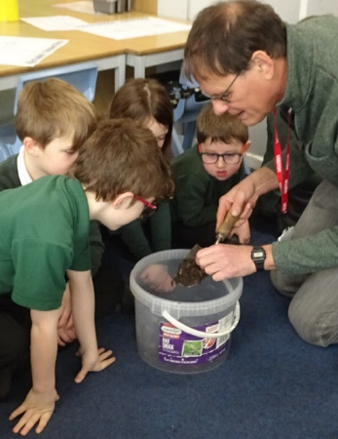
Dear parents/carers of Class 1,

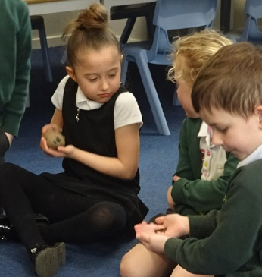
I hope that you have all had a wonderful 2 week break and are as excited for the summer term as I am! Our whole school exhibition at the end of the spring term was the perfect conclusion to a busy half term building connections with our learning and Class 1 were so proud to show off their work to their adults. We also enjoyed having lots of visitors in from the community last half term- the photos on here are from our morning with John and Paul from the Keyworth allotments. The children were fascinated with the collection of vegetables, gourds and worms! Our class topic this half term takes a science focus with life on the ocean waves, overleaf are further details of this… Any exploration of animal books at home (both fact and fiction!) will add to the excitement and discussion in class.

An advanced warning that we will be going on a class trip with reception class on Thursday 18th May to Rushcliffe Country Park! This will be a day spent exploring fairy tales in an outdoor learning environment. Further details will follow shortly.

Reading
Thank you so much for your support with reading at home. Their progress has been so clear to see and they are rightfully pleased when they are told that they are ready for some more challenging books. The expectation continues that children are reading aloud their school reading book with an adult (or older sibling!) at home each day and that this is recorded in their Monkey book by the adult (or older sibling!).

Please ensure that children have their reading record and reading book in school every day so that our reading sessions can be recorded and books changed. We continue to aim to change reading books daily when we can see from the monkey book that a book has been read. Each week, children will be heard reading aloud 1:1 by an adult in school at least once a week to continue to aid fluency, support important comprehension skills and build that all important love of reading! Your support with this at home is invaluable.

Phonics folders will continue to be sent home each week on Friday for you to interact with at home- please ensure they are back in school on Monday!

Homework
As has become the routine, homework will continue to be set on a Friday to be returned the following Tuesday. Our spelling quiz will also continue to be on a Friday.
This half term, we will be looking at different ways of measuring and comparing length, weight and capacity. This is a great excuse to do some baking at home and put this learning into a real life context! The Class 1 staff are always very happy to be taste testers for any maths done in the kitchen…!
Our PE days this half term will be Tuesday and Thursday. Please ensure children have a full kit in school so that they can take part in our lessons.

If you have any concerns or queries regarding anything on here or otherwise, please don’t hesitate to call me via the school office or catch me on the playground.

Mrs Humphrey

