**October 13th 2023**

Newsletter

**Parents Evenings**

Next week we look forward to welcoming you into school for our autumn term Parents Evenings. You should have received confirmation of your appointment time today on a slip Having a one-to-one conversation with you before half term is important to us, so if you have not yet returned your form, a member of staff will be in touch.

**School Photos**

On Tuesday next week the photographer will be in school for the morning. As always, we will take individual photos and organise any siblings in school to get together for a family picture.

**School Council**

It was an honour to welcome our newly elected school council on Monday. As one of the official British Values, we teach the children about democracy and every member is thoughtfully voted in by their classmates. One of our 5 C’s is *confidence,* and as each member of the class prepared and delivered their speeches with the courage of their convictions, the votes they received were perfectly cast. Our two Year 6 members will also have the pleasure of representing the school at the Rushcliffe Pupil Parliament at County Hall.

**Harvest and macMillan**

We have received a very sincere thank you from the Friary Drop-in Centre for your incredibly generous donations of food at our Harvest Festival last week.

After sending a magnificent £750 to MacMillan following our coffee breakfast the Friday before, it was a difficult task to pick some Bake Off medal winners… I hope that you have had a chance to see some of the amazing creations on the school website <https://willowbrook.notts.sch.uk/let-them-eat-cake/> but well done to Zoha, Ruari and Solomon whose showstoppers were worthy of a Hollywood Handshake!

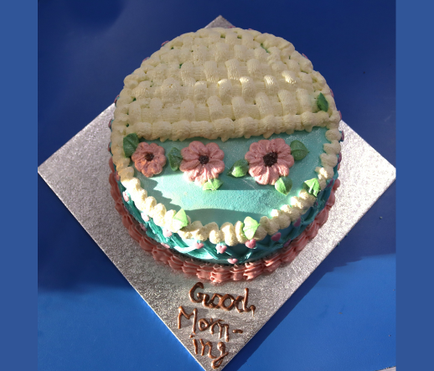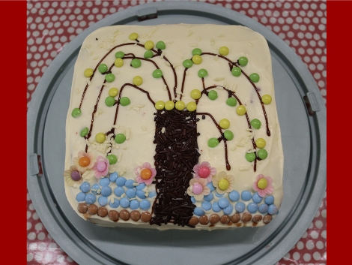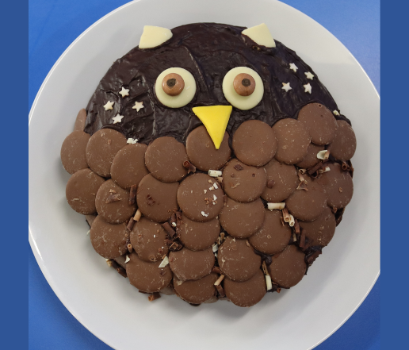

**Mrs. Hollingshead**

After nearly 20 years at Willow Brook, I am really sad to announce that Mrs. Hollingshead will be retiring at half term. Whilst many a child (and teacher!) do as they are told when Mrs. Hollingshead is in charge, everyone knows that they are safe and in good hands when they are in her classroom and company! She is (and always has been) a wonderfully practical ‘can do’ person who will serve others faithfully and has been a champion for so many children who needed a strong advocate and role model. I had the pleasure of Mrs. Hollinghead as my first TA as a new Willow Brook teacher... and I loved every minute! During the pandemic, she was a godsend, feeding and caring for staff on duty and constantly giving more than was asked of her. From cookery and bridge club to her annual chicks and visits to see the lambs, she has certainly added a unique touch to our school community. As with most important people, she is taking an early retirement to spend more time with her family, and I wish them all good health and happiness in their new chapter together.

**Dare we mention Christm…**

This week the children in Years 2 to 6 were excited to find out that our December production is going to be *Ali Baba and the Bongo Bandits.* The script is ready and we are raring to go with songs about magic flying carpets, secret caves full of treasure, genies and princesses. Our whole school topic captures a brilliant element of the primary history curriculum where we will learn all about The Silk Road and the Golden Age of Baghdad. Interwoven with that, is the stories from 1001 Arabian Nights, which will be at the heart of our work in English. From Sinbad to Aladdin, there are lots of tales to read and retell. And, of course, we hope that the production dates are already on your calendar!

**Friends of Willow Brook Events**

You will notice that the Friends Committee have also added dates to the calendar this week. The first school disco of the year is booked for November 24th and the team are organising a Christmas Fair on Friday December 1st between 4 and 6pm. The Friends’ Annual General Meeting will be held on November 13th at school. Details of how you can attend and get involved have been sent to you via Parent Mail.

**Traffic around Willow Brook**

I have been asked by several residents on the Fairway to politely remind members of the school community to park with consideration at peak times of the school day. We all know that obstructing a driveway, parking over a drop-down kerb, the bus stop area or within 10 meters of a junction is against regulations. When we see the Keyworth Connection struggling to get round the corner as children are trying to cross a busy road, it is clear that the consequences could be dreadful. I have received two emails from parents over the past year who have experienced a near miss with their children as they have walked to school and I know that not a single one of us would want to be the cause of an accident.

As well as getting our school council on board with a winter campaign, I would love to encourage you to consider one of the following options as we aim for a positive solution to the problem:

**Park and Stride** If you live further afield and need the car to get to school, stop on any nearby road and walk the final 10 minutes to or from school. It is great exercise and gives you 10 minutes to chat and share the day.

**A Willow Brook Wednesday Walk** Pledging to walk to school once a week is a great way to establish a new habit. After half term we will be making new merit incentive cards to reward the children who do!

**Bike or part-walk** We have purposely trained our Year 6 pupils in cycling proficiency early this year. Trusting them to cycle or scoot to school is something we’d encourage.

**A Walking School Bus** Organising children to meet a friend and share a walk or walking part of the way with them is a great way for older children to establish a healthy journey. One of our parents has said that she might be interested in starting a ‘walking bus’ to encourage more families to join together in the mornings and share the supervision to get everyone safely to school. If you are interested in this, please get in touch.

**Smart Watches**

As you are aware, children at Willow Brook do not bring their mobile phones to school. For so many safeguarding reasons, as well as the fact that phones are incredibly expensive items, we think that this is right. More and more children are now owning smart watches and our thinking is exactly the same. After recent incidents where texts have been received, where voices have been recorded without knowledge and where inappropriate photos have been taken, we would ask that smart watches are kept at home. A simple watch that has hands on it where children can learn to tell the time is a teachers dream!

As always, I leave you with an updated list of events on the school calendar and Mr Clarke’s latest sports report.

Have a great weekend.

Mrs Ballard

|  |  |  |
| --- | --- | --- |
| Date | Event | Details |
| October 17th | School photographer | |
| October 17th and 18th | Parents Evenings | |
| October 20th | Half term begins | |
| November 13th | Friends of Willow Brook AGM | 7pm in the school hall. If you are interested in being a part of the Friends team, please come along. |
|  | Phonics Information Evening | We invite our EYFS parents and carers to join us and learn a little bit about how we teach phonics and reading in school. 6pm |
| November 17th | Children in Need fundraising day | A fun-filled charity day where we will be dressing up and raising money. |
| November 24th | School Disco | Key stage One 6.15pm to 7.15pm  Key stage Two 7.30pm – 8.30pm |
| December 1st | Friends Christmas Fair 4pm to 6pm in the school hall | |
| December 2nd (Saturday) | The Junior Choir will be joining the Village Day Christmas celebrations 2.30pm | |
| December 12th 13th 14th | Junior Production – Ali Baba and the Bongo Bandits | Years 2 to 6 perform on Tuesday, Wednesday and Thursday evenings. |
| December 20th | Nativity Day | EYFS and Year 1 perform their nativity at 2pm and 6.30pm |
| December 22nd | End of the autumn term | Children return to school on Monday 8th January |

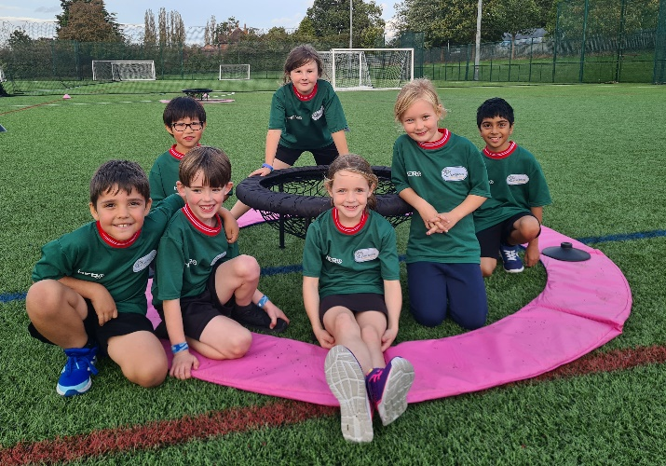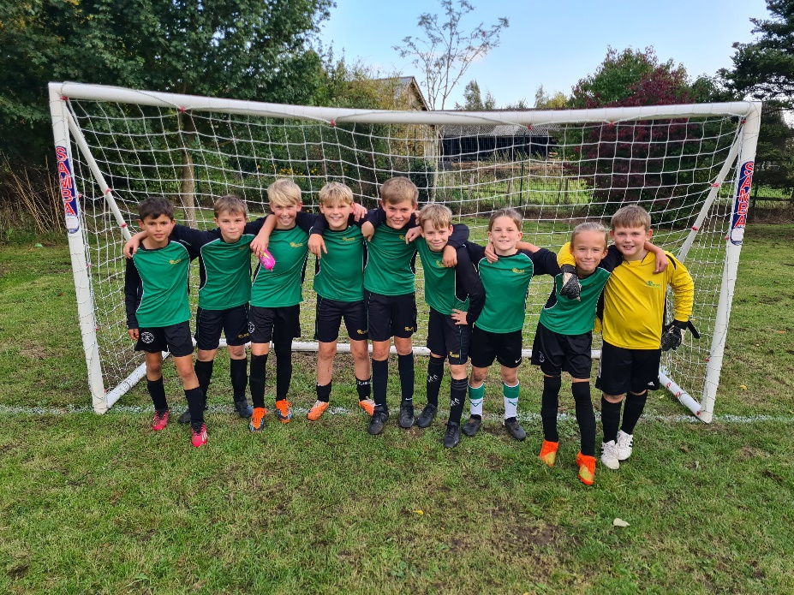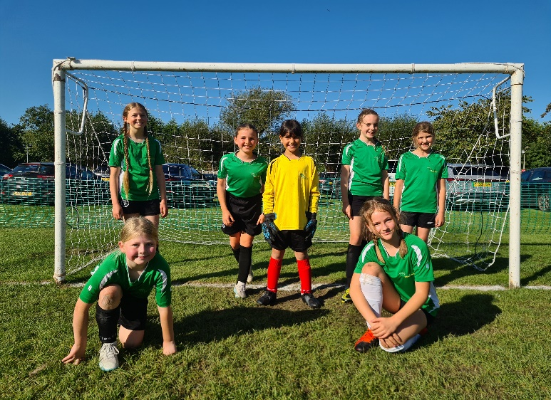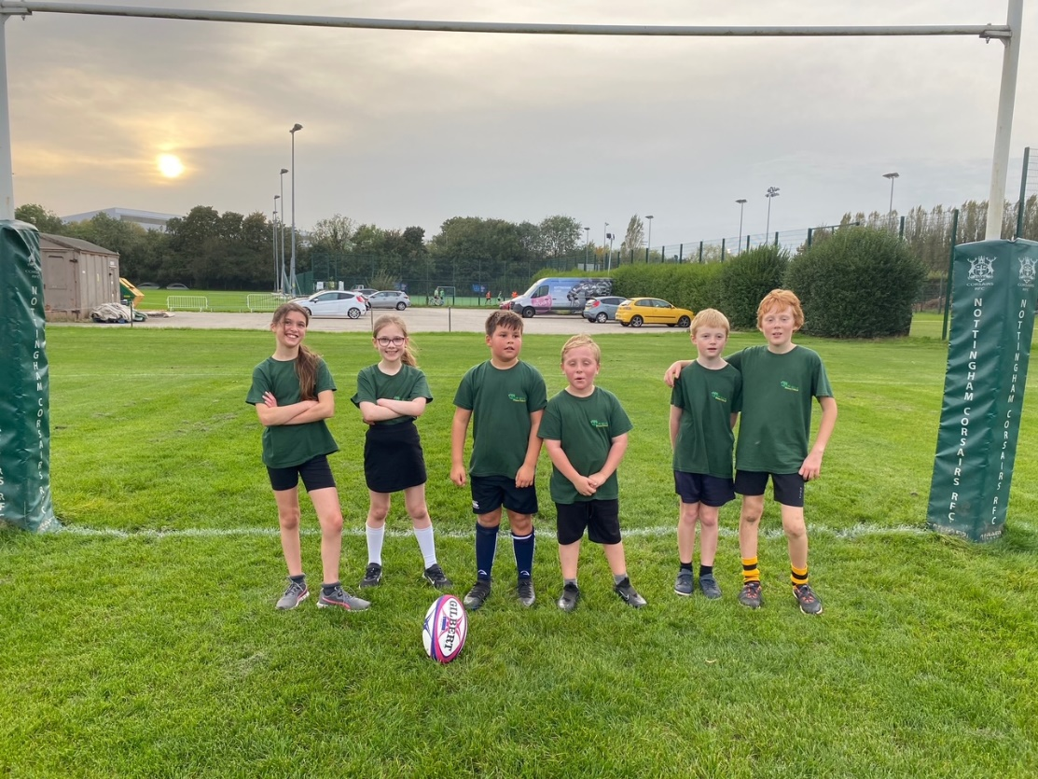

Mr. Clarke’s Sports Page

Mr. Clarke has kept the world of Willow Brook sports on its toes this half term and has given lots of children the chance to put on a school kit and compete.

From Saturday morning tournaments to cup and league games, the girls and boys football teams have battled on and we celebrated our first victory last week! After Miss Johnston discovered paceball on a recent training course, she was keen to get a squad to a tournament. Mr. Clarke and the children enjoyed themselves so much, that I know this will be a regular game in school. Two evenings this week have been spent on the Nottingham Rugby Club training pitches with teams from every year group in key stage 2.

Before the dark evenings set in, the football teams play their cup matches next week. Mr. Clarke is always keen to welcome a supporting crowd so if you are free Monday after school, do come along!