

*Year 4 Learning Letter*

*Autumn 1*

*Miss Watterson*

***Welcome back***

Hello everyone! I hope you all had a lovely holiday, enjoying the sun (what little there was…) and getting some well-needed rest. I spent the first part of my summer in Majorca where I had the opportunity to mountain buggy! I enjoyed the summer reading in the garden and spending time with my family. I cannot wait to hear what you all got up to during your time off.

Whilst most of you know me, I thought I would reintroduce myself and tell you a little about me! This is my second year at Willow Brook, and I am very excited to be teaching you this year. I thought a fun way for you to get to know me is by doing 2 truths and a lie... 1. I have a black belt in karate 2. I have been to America 3. I had a dog named after a character in Biff, Chip and Kipper.

We are very lucky to be joined for some of our lessons this year by Mr Clarke, who we will also be having PE with on a Thursday. I even got him involved… 1. Mr Clarke can speak fluent Spanish 2. He has a brother 3. His girlfriend has a pet tortoise.

We hope you are excited to hit the ground running as we enter into our exciting first topic, the Romans.

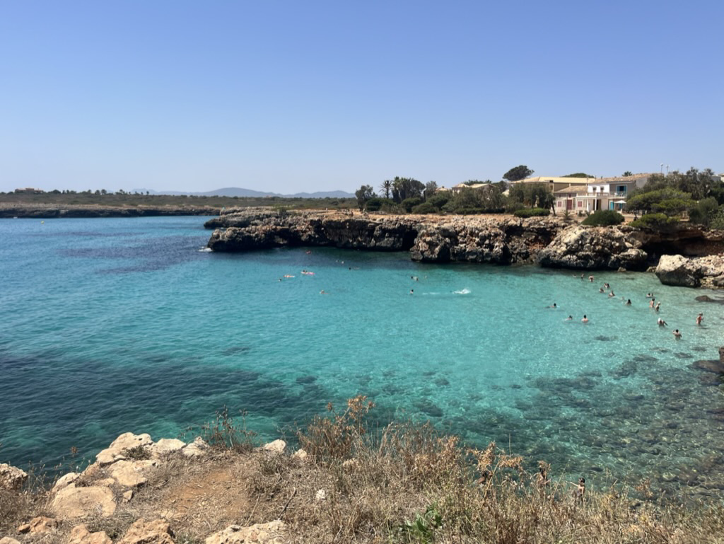

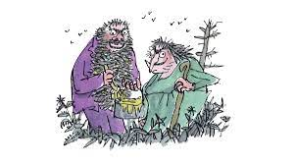

**Home Learning**

**Handed out Friday – Returned Friday**

*Reading*

We will provide your child with books from school to read at home. Please try to read as frequently as possible and sign the relevant part of the reading diary. It is really important they still read with adults at home – thank you in advance!

*Homework*

Each week your child will have a piece of homework to complete related to their learning that week. As the half term progresses, I will start to introduce purple mash activities to help support their times table knowledge. I will send out a letter with logins and information later in the term.

*Spellings*

In Year 4 the children will have a spelling lesson every Thursday, during this time last week’s spelling will be tested and we will go over this week’s spelling rules and spellings.

**What are we learning?**

*Our first topic*

As a whole school we’re starting off by looking at Roald Dahl. In year four, we are focusing on ‘The Twits’. We will have the opportunity to learn more about these fantastic characters and the different pranks they pull on each other. To start of our journey, we will be turning ourselves into The Twits characters!

**More than Conquerors**

*Autumn 1 Learning*

To find out more about what we are learning this half term, please see the reverse of this letter.



If you do have any questions or concerns that I can help with, please feel free to

catch me on the Playground.

**PE**

Year 4 will be doing hockey in PE this half term, our PE days will be Wednesday and Thursday, however, there may be occasions for PE sessions on different days. Please ensure children always have their correct PE kit in school – We appreciate the support!

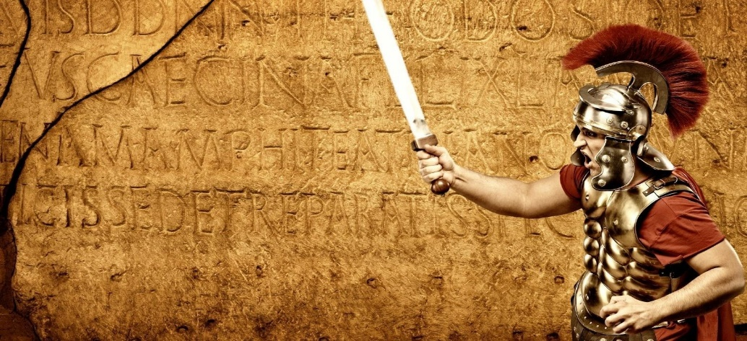

**What Did the Romans Ever Do for Us?**

**The Big Idea…**

***‘Those who read about the Romans get to know not the history of one city but also mankind’* Florus**.

In this half term topic brimming with historical fact and gripping fiction, Year 4 will be considering how the Roman civilisation influenced the society we live in today. We will be recreating aspects of Roman life immersing ourselves in the food, fashion, art and pleasures of Roman Britain.

The topic will also give us chance to consider what a European Empire might look like today? How would British values stand? … Would Boudicca have been proud of modern Britain? Questions that we will, no doubt, be able to answer by the end of the topic.

**As mathematicians we will**

In maths we will be working on place value and the number system to get us started. We will be able to read, write and partition numbers with increasing accuracy above and beyond 1000. Learning how to round numbers to the nearest 10, 100 and 1000 will also be covered during the half term. We will become fluent in different methods for addition and subtraction, focusing both on our mental calculations as well as the formal written method using columns. Of course, we will also be learning to read, write and work with Roman numerals and will probably end up feeling quite lucky that we didn’t go to school in ancient Rome!

**As language specialists**

The start of the term sees a whole school celebration of Roald Dahl and we will be soaking up the silliness of Mr and Mrs Twit! We will be writing our own descriptions in the style of the master as well as understanding the art of simple but effective character portrayal.

Class 4 will then be reading and engaging with both fact and fiction texts to support our knowledge of Roman history. We will meet a number of new authors and a variety of genres to broaden our experience. Key authors will guide our writing techniques – Philip Pullman’s story The Firework-Maker’s daughter will take us on an adventure. With Judith Nicholls, we will open up the world of Roman poetry. We will be looking at rhyming couplets and rhythm for performance from memory. Summarising, paragraphing and presenting non-fiction accounts will also be on the agenda. Grammar, punctuation and spelling will be taught in explicit lessons as well as through extended writing projects and published pieces.

As geographers we will

learn about the geography of Britain and then Europe as we map the area that was conquered by the Romans. We will be learning the main rivers, mountains, seas and coasts of Europe, the Middle East and northern Africa. Understanding Roman journeys will open our eyes to physical features and land use to the present day.

*‘Pupils will be taught to locate the world’s countries, using maps to focus on Europe seeing key physical and human characteristics, countries, and major cities…human geography, including types of settlement and land use, economic activity including trade links, and the distribution of natural resources…’*

As historians we will

use primary and secondary sources to learn all about the Roman invasion. From settlement in Britain to lifestyle, celebration and warfare, Year 4 will unearth all that this ancient civilisation has to show us about conquest, leadership and the resulting impact that shaped British history. We will learn about reliable sources and primary evidence as we look at artefacts and famous Romans.

*‘Pupils will be taught about the Roman Empire and its impact on Britain. …Julius Caesar’s attempted invasion in 55-54 BC; the Roman Empire by AD 42 and the power of its army… British resistance, for example, Boudica’*

As scientists we will

Investigate states of matter from solids and liquids to gases. We will be learning how science helped the Romans to keep their wine at the right temperature before moving on to investigate and observe the weather! Other practical investigations will enable us to establish fair tests and draw conclusions from our observations.

*‘Pupils should be taught to:*

*compare and group materials together, according to whether they are solids, liquids or gases; observe that some*

*by evaporation and condensation in the water cycle and associate the rate of evaporation with temperature…’*

Across the curriculum

**As musicians** –We will be coming back together and experiencing the power of music through singing. We will learn about musical structure and dynamics and learn how composers achieve different effects through their compositions.

**As expressive artists –** we will be using our sketch books to record a study of Roman portraiture, both sculpture and relief. We will understand how artists communicate history through portraits and compare the classics to more modern techniques artists such as Alberto Giacometti, creating pieces inspired by his work.

**As PSHE experts** - we will learn about positive, healthy relationships. We will learn about family and friendship and how to manage conflict and appreciate difference.

**As fitness experts** – we will be exploring movement, developing flexibility, strength, technique, control and balance in gymnastics. The class will be performing a sequence of movements on the floor and low-level apparatus with travelling sections in between to create polished routines.

**As philosophers**

In Religious Education Year 4 will be understanding more about the journey of life. This touches on aspects of Christianity, Hinduism, Islam and Humanism.

**Knowledge of the World**

By understanding how Britain changed under Roman occupation, we will start to appreciate how language, engineering, food, leisure and learning all evolved. The Romans did, in fact, do quite a lot for us!

**Citizenship and British Values**

By learning about a Roman’s way of life we will understand how an organised civilisation came into being. What similarities exist in Britain today and how do we structure society so that it works democratically for all.

**Ambitious thinking**

Could an invasion as strong as the Romans resurface? Would America’s ideas of ‘building a wall’ really keep invaders out? Do migrants have a right to share our country or are boarders important?