
Year 4 Learning Letter
Summer 1
Miss Watterson

Welcome back!
Hello everyone! I hope you had a fantastic Easter break, and you are ready for the half term ahead! I cannot believe we are entering into the last term of the year. We are going to jump straight into our short half term topic, ‘Do Androids Dream of Electric Sheep?’ All will be explained…

Last half term’s whole-school theme of Wacky Rally allowed us to think both scientifically about how objects move when force is applied, whilst using their DT knowledge to build their own moving vehicles. Year 4 worked really hard last half term, and I cannot wait to see what we can achieve together over the next six week half term.

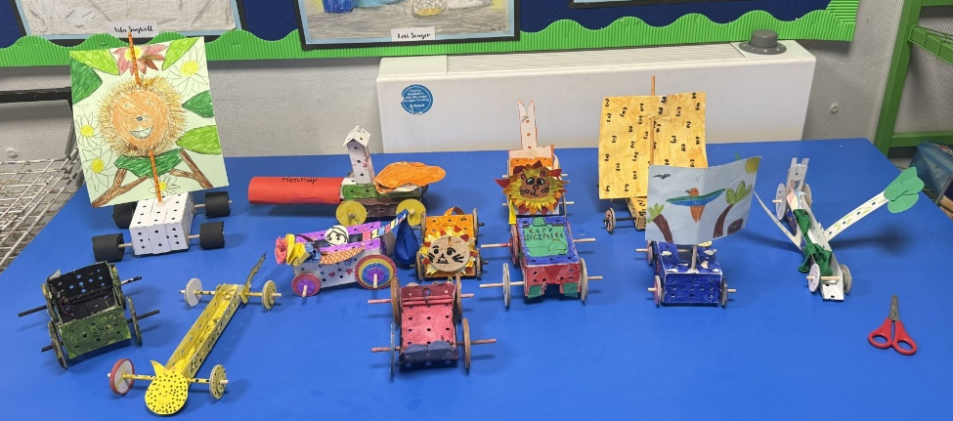

Home learning and information:
Thank you for the continued support with reading at home, it makes such a difference to their understanding. Keep it up Year 4!

Homework will continue to be set every Friday, due the following Thursday. As we enter into the summer term there are lots of exciting Times Tables Rockstar tournaments and challenges, we really want to beat the other classes! This is especially important as we get closer to the Year 4 multiplication check. Our Spelling lesson and dictation will also be moving to a Thursday this half term.

In PE we still have 2 more swimming lessons before will be working on our netball and cricket skills in our PE lessons. It is wise in the summer to keep a PE kit in school for any additional sessions, but lessons are timetabled for Wednesday and Thursday.

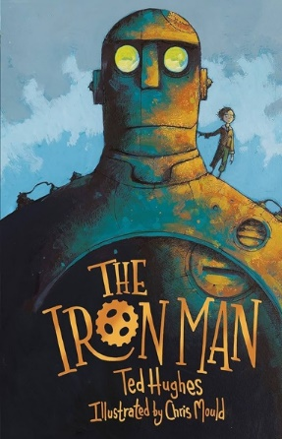
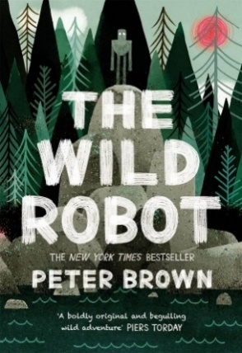

What are we learning?
This half term our class topic is, ‘Do Androids Dream of Electric Sheep?’ We will exploring how electricity and circuits work. As a class we will be learning all about electricity and technology, which will thread through all aspects of our learning, from our class text The Iron Man by Ted Hughes to The Wild Robot by Peter Brown. For more information about every area of the curriculum, please refer to the half term’s Creative Curriculum document.


If you do have any questions or concerns that I can help with, please feel
free to catch me on the playground.

